**Database**



**Mahnoor Islam**

**58155**

**BSCS-3B**

**Question 1:**

Write an SQL query to find the total number of hours worked by each employee across all tasks.

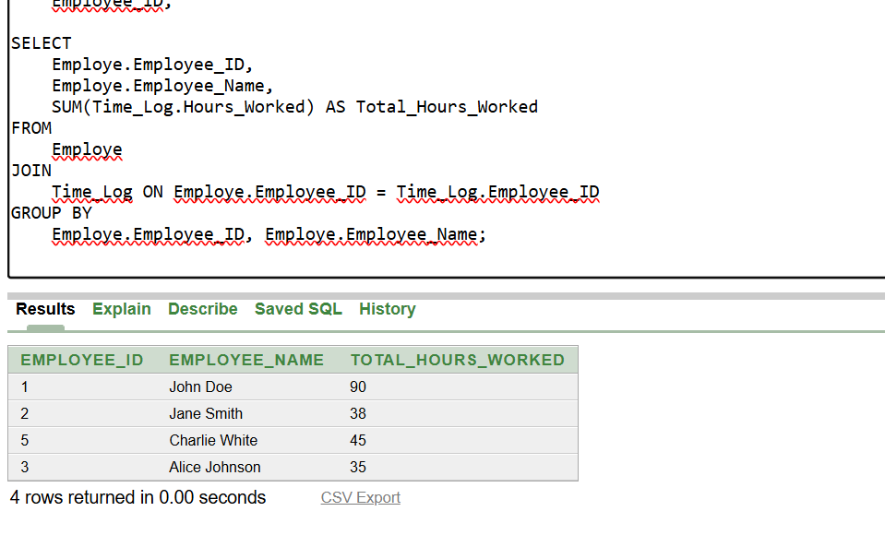

**Question 2:**

Retrieve all projects that were completed after 2020, including their project name and client name.

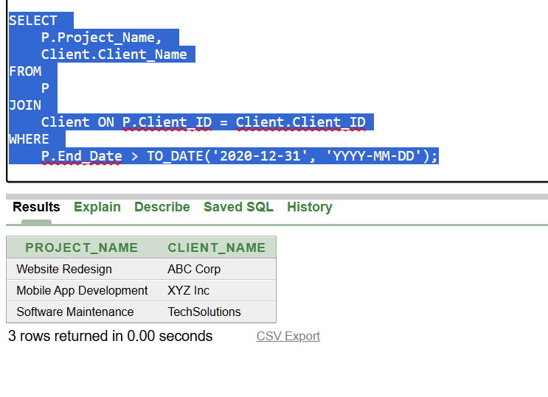

**Question 3:**

List all employees who have worked on a project that was completed before 2021. Show the employee name, project name, and task status.

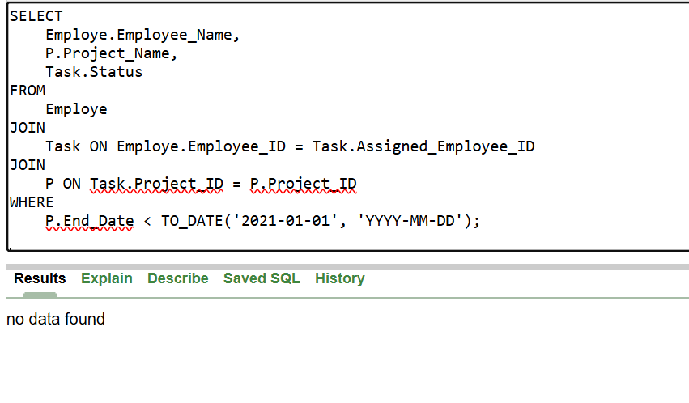

**Question 4:**

Find the total number of tasks completed in the "Development" department, and show the department name and total tasks completed.

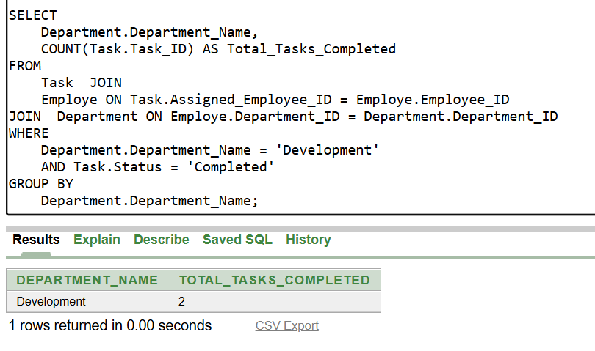

**Question 5:**

Retrieve all tasks with their assigned employees, but only for tasks that have been assigned to employees with the role 'Developer'.

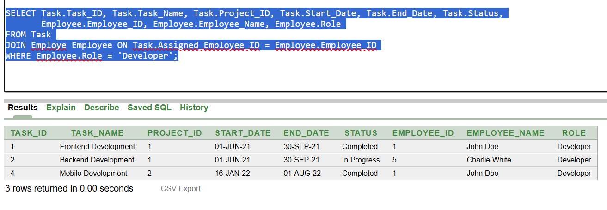

**Question 6:**

Find all clients who have projects with deliverables due in the next 30 days. Show the client name, project name, and deliverable description.

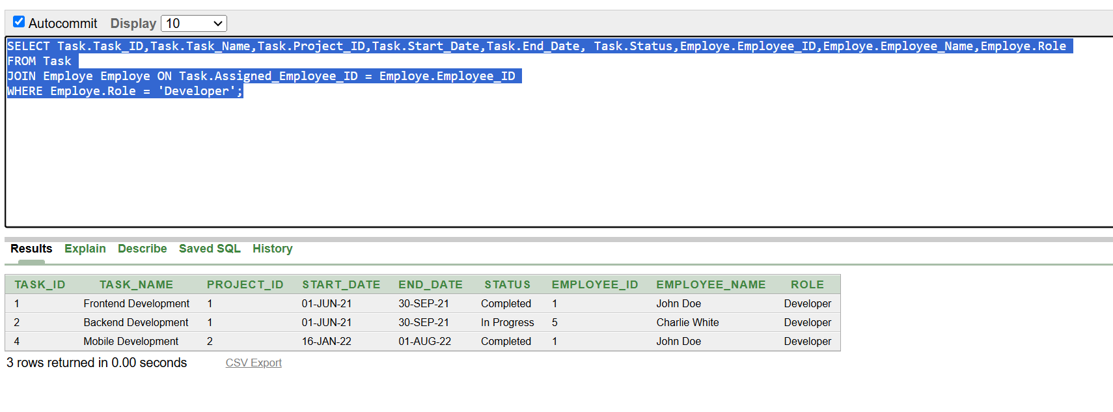

**Question 7:**

List all employees who have worked more than 40 hours in a week (considering time logs within the same week).

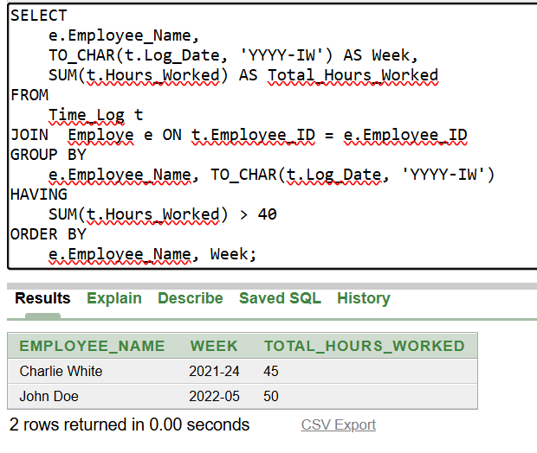

**Question 8:**

Retrieve the department-wise total salary paid to employees, and show the department name along with the total salary amount.

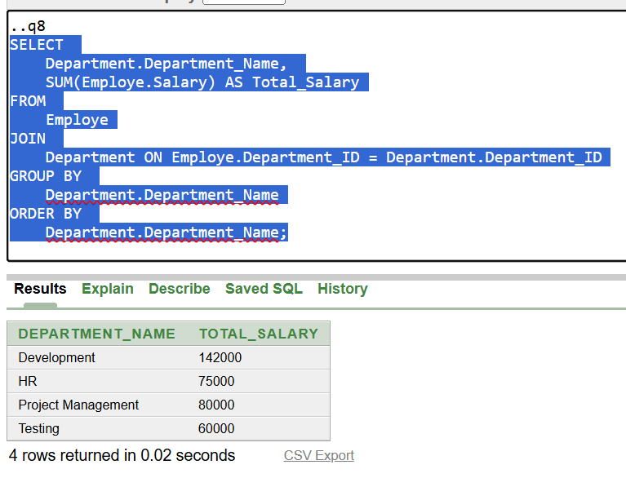

**Question 9:**

Find all employees who have not worked on any tasks from the project "Website Redesign".

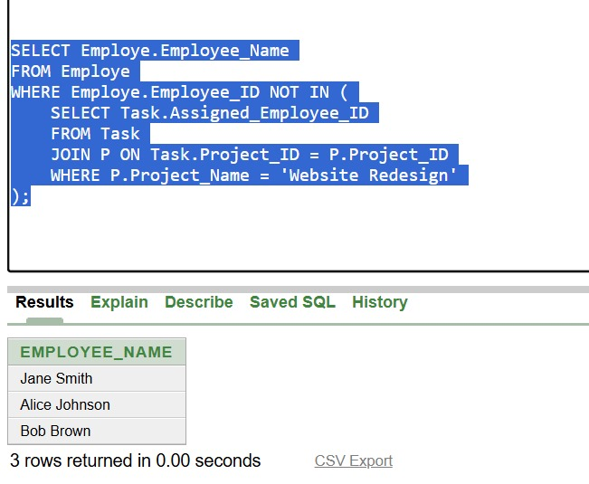

**Question 10:**

List all tasks with their corresponding project names, along with the number of hours logged for each task.

